3.1 Functions of Two or More Variables

Definition: A function f of two variables is a rule that assigns to each ordered pair of real numbers in a set D a unique real number denoted by . The set D is the domain of and its range is the set of values that takes on, that is, .

Note: Familiar operations like addition can be written as a two variable function. For example, the function is the function which spits out the sum of two numbers. Using our mapping notation we can write .

Example 1: Consider .
- Find .

We note .

- Write the domain of in set notation.

In order for to be in the domain of , we need and . Thus the domain of is .

- Sketch a picture of the domain of .

A picture is (points in the domain are shaded yellow):
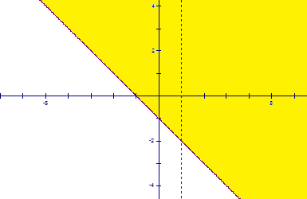

Example 2: Write the domain and range of the following function in set notation: .

First, for to be in the domain we need . Thus, the domain of the function is . Since and are both nonnegative numbers, we know that can be no larger than , and in fact, . Also, since the range is not to include complex numbers, the smallest value that can be is 0, and in fact, . So the range of the function is .

Exploration:
From the above example we see that we can think of as the z variable. Thus, we can graph a function of two variables in . Moreover, the graph of a two variable function is a surface in .

The instructor will use the three dimensional plotter to graph the function from the most recent example. The instructor will also graph it by hand (the graph is a hemisphere).

Intuitively, when we graph a two variable function we can think of plotting points, above, below, or in the domain region (there are nice illustrations of this throughout section 13.1 in the book).

Definition: The level curves of a function of two variables are curves with equations , where k is a constant in the range of .

Note: Level curves are closely related to trace curves, and are very helpful when sketching a graph of a two variable function by hand.

Example 3: Consider the function .

- State the domain and range of this function.

Since plugging any in will produce a real number output, we know that the domain is . The smallest that can be is , and can get arbitrarily large. So, the range of the function is .

- Sketch the level curves for the function for the values .

We note that if , then . So, the level curves are:

- Sketch a graph of .

A sketch is:
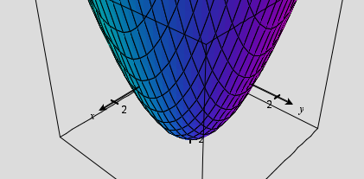

Note: We recognize the function in this example as having a graph which is an elliptic paraboloid.

Note: Two dimensional graphs of level curves (as we saw in part (b)) of the most recent example are used frequently in topographic maps of mountainous regions and are called contour maps.

Question to the Class: What does the graph of look like?

This linear function represents a plane with normal vector .
Definition: A function of n variables is a rule that assigns a number to an n-tuple .

Remark: If functions of n variables can be very difficult or impossible to picture visually. One simple example of how one might picture a function of 3 variables is representing how a surface changes over time.

For example, consider the function . If we think of as being a time variable, the surface is a sphere of radius one when time is one, a sphere of radius 2 when time is 4, etc
(Note: This is certainly not the only way one might interpret this function).

Example 4: At a bakery there are n ingredients used to make all possible items. Suppose that represents the number of units of the ingredient used by the bakery on a particular day. Suppose also that the ingredient costs per unit.

- If is the daily expense function (on ingredients) for the bakery, find a formula for .
One way to write it would be . Another way to write it would be .
- Write the domain of the function in (a) in set notation.

We assume that the bakery cannot use a negative amount of an ingredient. So, the domain is .

